

**Faculty of Engineering & Technology**

**Electrical & Computer Engineering Department**

**COMPUTER ORGANIZATION AND MICROPROCESSOR-Lecture-1202 - ENCS2380**

**Assembly Project**

**Prepared by:**

**Amany Khdair 1190728**

**Partners:**

**NO PARTNER**

**Instructor**: **Dr. Abualseoud Hanani**

**Section:** **2**

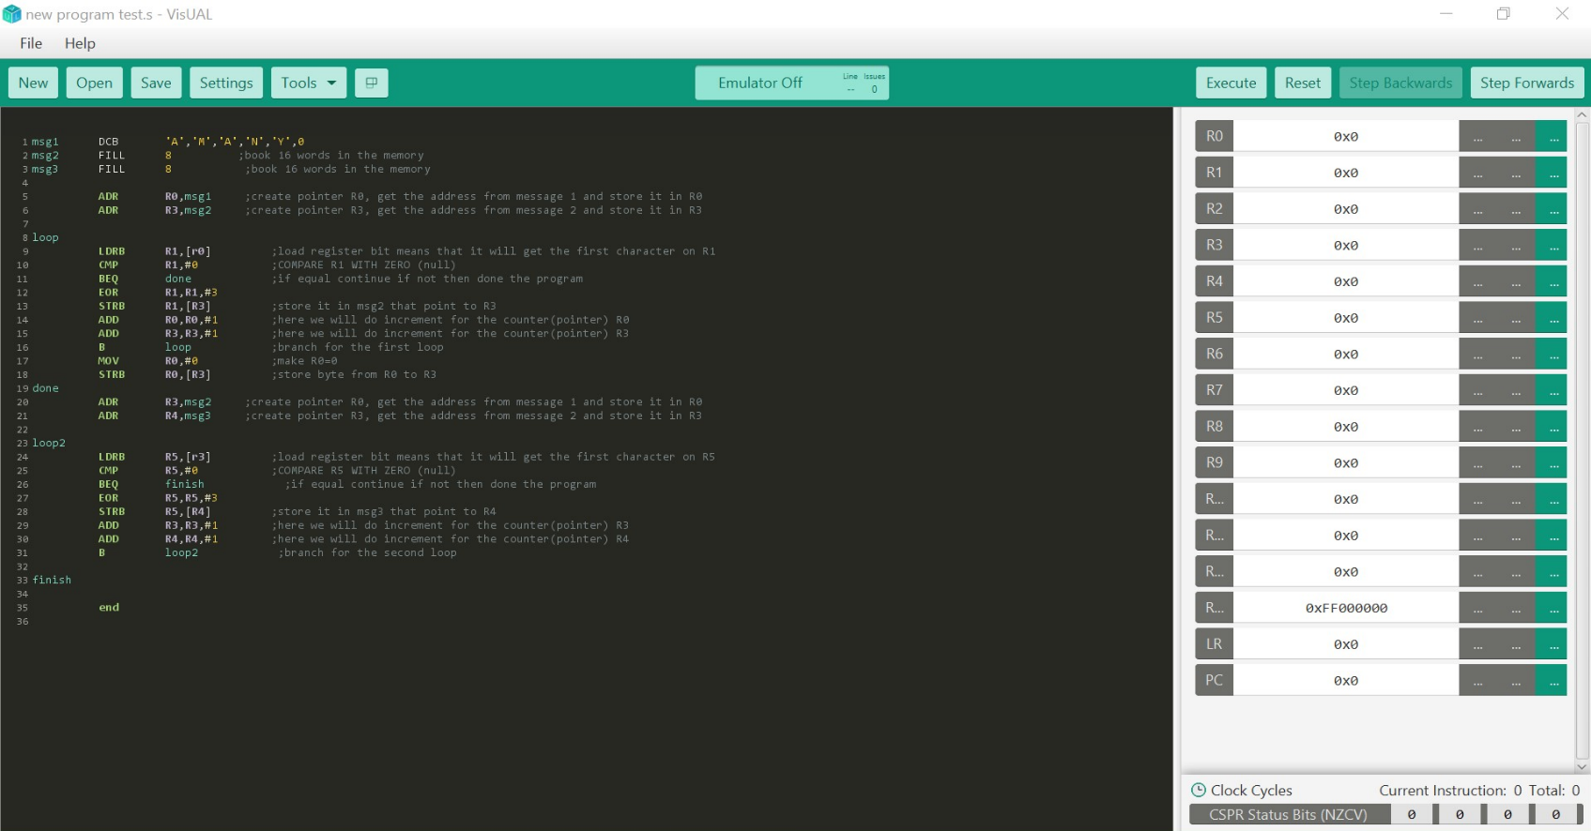**CODE:**

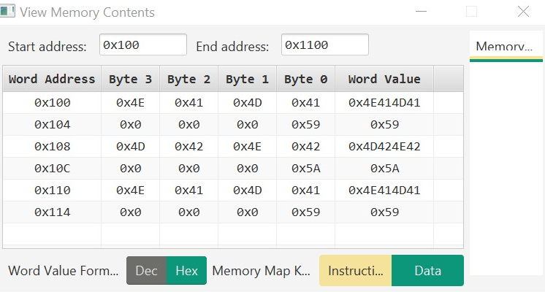**SIMULATOR:**

**DISCRIBTION:**

The character we have are A, M, A, N, Y

And the ASCII code for each one is as follow

A = 41 Hex and in decimal 65

M = 4d Hex and in decimal 77

A = 41 Hex and in decimal 65

N = 4e Hex and in decimal 78

Y = 59 Hex and in decimal 89

Now we will transform the decimal value to binary value

A = 65 -> 1000001

M = 77 -> 1001101

A = 65 -> 1000001

N = 78 -> 1001110

Y = 89 -> 1011001

Invert the first 2 bit then it will become ->

A = 1000001 -> 1000010 -> 42

M = 1001101 -> 1001110 -> 4E

A = 1000001 -> 1000010 -> 42

N = 1001110 -> 1001101 -> 4D

Y = 1011001-> 1011010 -> 5A

So, I have show that what was shown in the view memory contents is true. And I hope I was good at describe how it was going

*Note: the above was for the encryption, and for the decryption it will return the original value so as shown in the memory contents

*Another note: I had to use the visual program due to some error in the Keil program.

**THE END 🎆❤**